Solution Requirements (Functional & Non-functional)
Project Design Phase-II

Date | 12/09/2026
Student Name | Navya Sri Tangellamudi
Project Name | Intergalactic Space Travel Request System (ISTR)
Maximum Marks | 4 Marks

Overview
ISTR's requirements are captured at two levels: seven Functional Requirements (FRs) describing what the system does, each broken into concrete sub-requirements; and seven Non-Functional Requirements (NFRs) describing the quality attributes the system must uphold while doing it. Together they form the contract the rest of the design — data flow, technology stack, and sprint backlog — is built against.

Functional Requirements Breakdown
The diagram below visualizes all seven Functional Requirements as a single breakdown structure, with the number of sub-requirements under each.
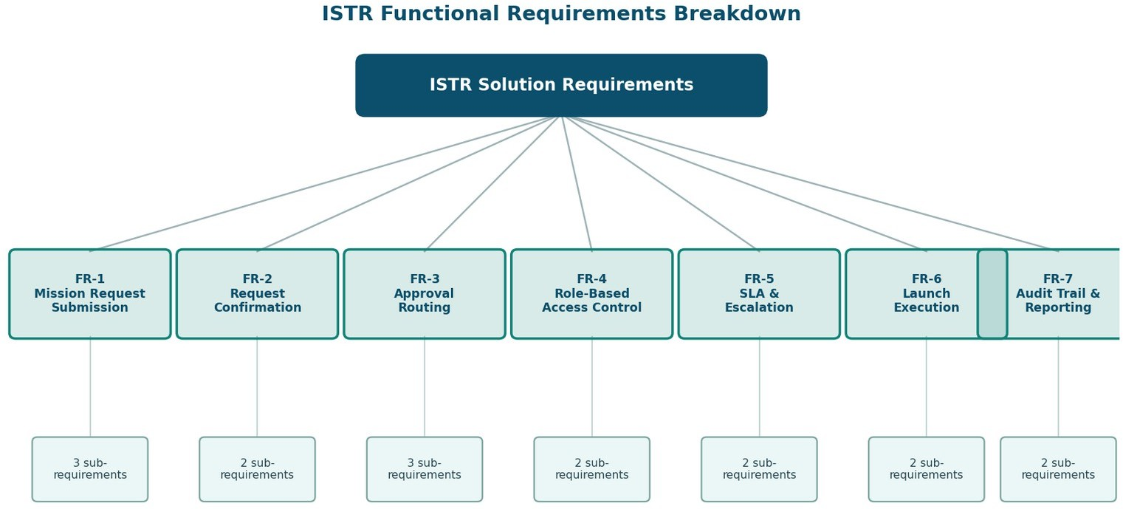

Figure 1 — ISTR Functional Requirements Breakdown
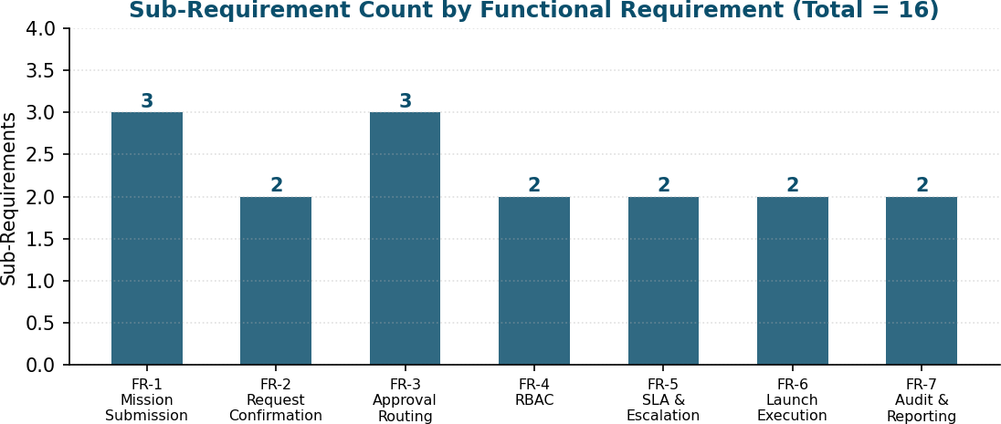
Figure 2 — Sub-Requirement Count by Functional Requirement

Functional Requirements:
Following are the functional requirements of the ISTR solution.

FR No. | Functional Requirement (Epic) | Sub Requirement (Story / Sub-Task)
FR-1 | Mission Request Submission | Submission through the Service Catalog item / form • Submission with destination, mission type, risk level, cost, and launch date • Conditional fields for special mission types (e.g., Diplomatic Officer for Alien Negotiation)
FR-2 | Request Confirmation | Confirmation via email on submission • Confirmation via in-app notification
FR-3 | Approval Routing | Auto-lookup and routing to the Requester's Manager • Routing to Finance Officer for budget review • Conditional routing to Mission Control for High/Critical risk missions
FR-4 | Role-Based Access Control | Access restricted by role: Requester, Manager, Finance Officer, Mission Control, Admin • Field-level and record-level ACLs based on group membership
FR-5 | SLA & Escalation Management | SLA timer per approval stage • Automated escalation/reminder notifications when SLA nears breach
FR-6 | Launch Execution | 'Launch Mission' UI action restricted to Admin role • Action available only when request state = 'Ready for Launch'
FR-7 | Audit Trail & Reporting | Logging of every state change, approval, and rejection • Role-specific dashboards with status tracking and reporting widgets

Non-Functional Requirement Pillars
The seven NFRs act as cross-cutting constraints that apply across every functional requirement above — none of FR-1 through FR-7 is considered complete until it also satisfies its relevant quality attributes below.
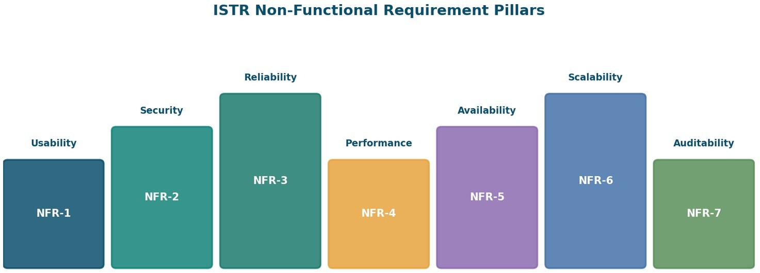

Figure 3 — ISTR Non-Functional Requirement Pillars

Non-functional Requirements:
Following are the non-functional requirements of the ISTR solution.

NFR No. | Non-Functional Requirement | Description
NFR-1 | Usability | Role-specific, intuitive UI with tooltips and contextual help text so each stakeholder sees only what's relevant to their role.
NFR-2 | Security | Strict least-privilege access via roles/groups and ACLs; sensitive mission data (cost, risk, diplomatic details) visible only to authorized roles.
NFR-3 | Reliability | Flow Designer automations execute approvals, notifications, and state changes consistently, with no manual intervention required.
NFR-4 | Performance | Form loads, approval routing, and dashboard queries return within acceptable response times even as request volume grows.

NFR No. | Non-Functional Requirement | Description
NFR-5 | Availability | The system remains accessible during standard mission-operation hours, with Update Sets enabling low-downtime migrations between instances.
NFR-6 | Scalability | Modular architecture (custom table, Flow Designer, role-driven security) supports adding new planets, mission types, and approval stages without core redesign.
NFR-7 | Auditability | Every approval, rejection, and state transition is timestamped and traceable for compliance and post-mission review.

Requirements Traceability
- FR-3 (Approval Routing) and FR-5 (SLA & Escalation) are the direct system response to the Engage-phase friction identified in the Journey Map — the highest-negative-sentiment stretch of the requester's experience.
- FR-4 (Role-Based Access Control) and NFR-2 (Security) are implemented together through the same ACL/role/group mechanism described in the Technology Stack document.
- FR-7 (Audit Trail & Reporting) and NFR-7 (Auditability) both trace to the same underlying log of state changes — one is the feature, the other is the guarantee behind it.
- Every FR above is realized as one or more user stories in the Data Flow Diagram & User Stories document, keeping requirements, data flow, and backlog consistent with each other.

